**Final Project**

**Submitted By: Haroon Imran-14723**

**Screenshots and video:**

**Photos:**

**1:When I run:**

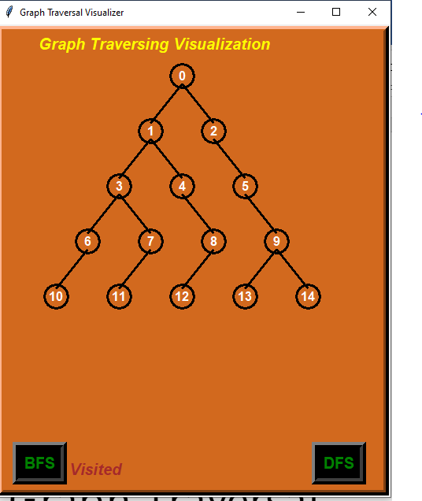

**2:when I clicked on BFS(breadth first search):**

**First visited on that which comes first due to (FIFO)**

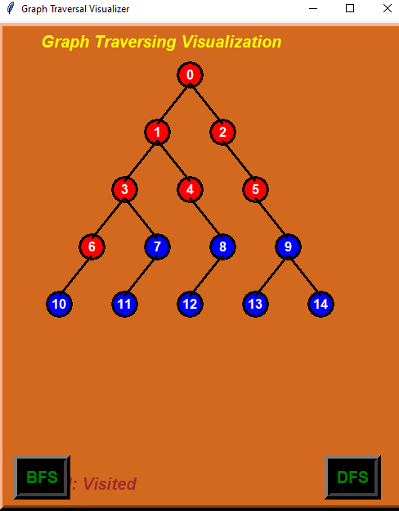

**After that visited on that which comes Last due to (FIFO)**

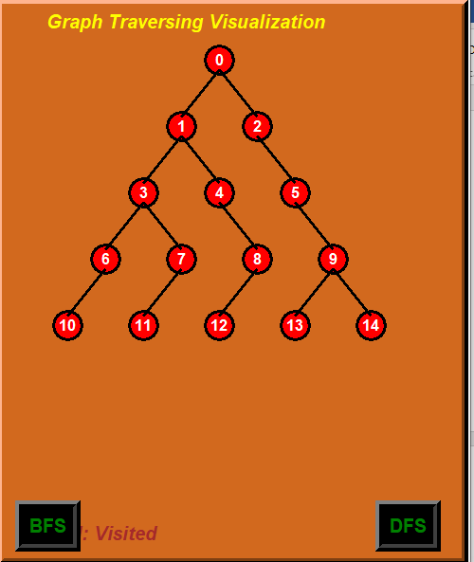

**3:when I clicked on DFS(Depth first Search):**

**First visited on last comes due to (LIFO)**

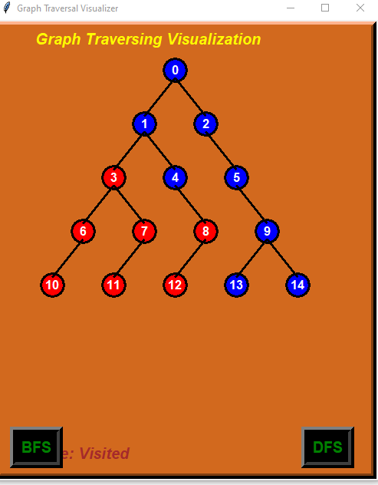

**After that visited on that circle which comes first due to (LIFO)**

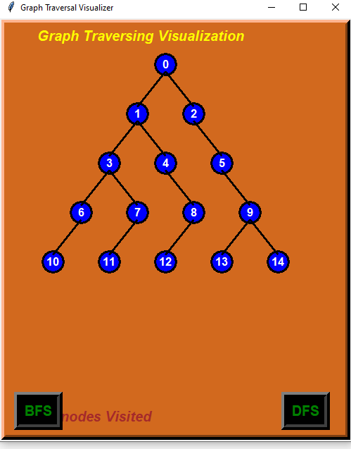

**Video:**

